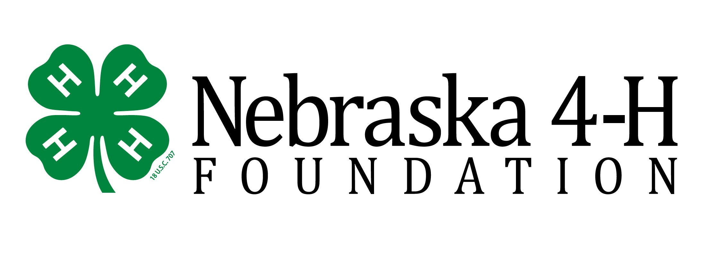
Dear Trail Riders:

We are excited to have you join us on our 4-H Trail Ride on Oct. 6-7! It’s going to be a great weekend of wonderful rides, great food and warm fellowship.

Many early birds enjoy arriving on Friday. There is a panel party at 4:00 p.m Friday, October 5th. If you’d like to join the set-up crew, we would enjoy your company.

On Saturday morning, registration will begin at 9:00 a.m at Windmill 25. All riders should be ready to ride by 9:30 a.m. You’ll meet the staff and receive instructions for the first ride which begins at 10:00 a.m.

Saturday evening will be a fun evening of great food and wonderful company. Supper begins at 6:00 p.m. at Eppley Lodge. At 8:00pm, there will be a bonfire that all are welcome to attend.

On Sunday morning at 9:00 we will have a breakfast. At 10:00 a.m., we will begin our Sunday trail ride. We will have at 1:30pm and then clean-up will begin at 2:00pm.

Please take a few minutes to review the following information:

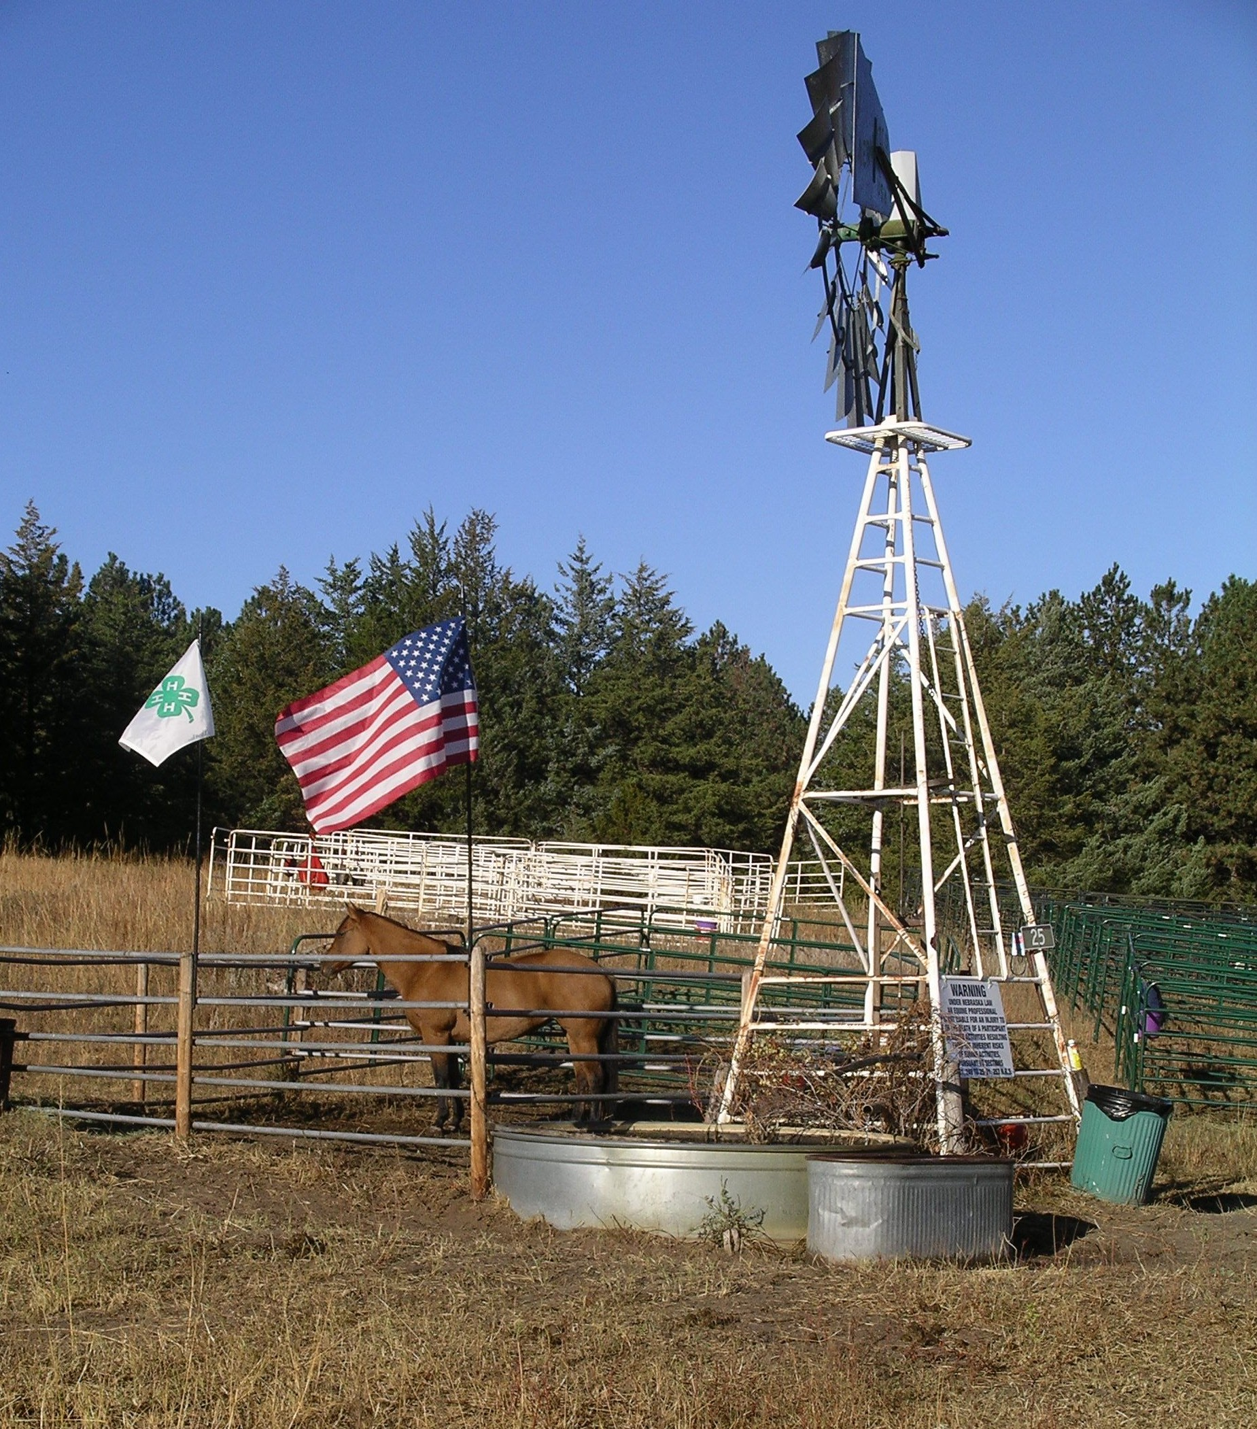
Companion Animals - Companion animals will not be allowed on the trail rides. While at the campsite, companion animals must be on no more than a six-foot leash at all times.

Use caution on the road to Windmill 25 - After leaving the paved road, the gravel/sandy road is narrow, winding and sometimes rough. Vegetation continues to grow along the edges and visibility is limited. Passing is difficult, so please take your time and be careful.

Parking - Please park in an orderly manner, keeping a safe distance from other trailers and horses. Someone will be available to help you with parking.

Hay for horses - The National Forest Service requires that we use certified weed-free hay. Certified weed-free hay will be available for a freewill donation. All hay will be checked for certification tags and papers.

Pens for Horses - Pens made from portable corral panels will be available for horses. Due to limited space, horses may be penned together when possible. The pens are set up and taken down by volunteers so we are always looking for help to make this job faster and easier!

Help us keep the area clean – Please help by keeping your camp area clean. When you’re ready to depart, please make sure everything is picked up and that manure, hay and bedding are spread out.

Lunch - We will return to Windmill 25 for lunch. Lunch meals are to be pre-ordered on your registration form.

Fire Safety - There are no fire restrictions at this time. Please be careful with open fires.

We are looking forward to seeing you this weekend and appreciate your support of Nebraska 4-H! If you have questions, please call 308-324-5501 or contact any of the trail ride committee members. More information about the ride can be found at: www.ne4hfoundation.org.

Yours in 4-H!
The Trail Ride Committee

